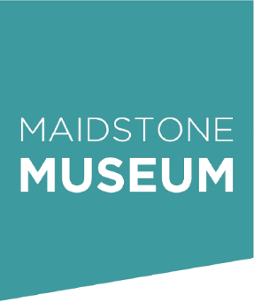
Maidstone Museums, St. Faith's Street
Maidstone, Kent, ME14 1LH
Telephone: +44 (0) 1622 60283
Email: museumevents@maidstone.gov.uk
Please adjust the box sizes as necessary.

Maidstone Museum Community Board – Application Form
Name: ..............................................................................................................................
Address:.............................................................................................................................
.....................................................................................................Postcode:......................
Tel:...................................... Mobile:.........................................
E-mail (required)..............................................................................................................
Tell us a little about yourself (skills, interests and life experience):

Why are you interested in contributing to this board?:

How do you think Maidstone Museum could improve its relationship with communities?

Are you currently involved with any other local groups, organisations or projects?

Thank you for completing this application form. Please send the completed form to museumevents@maidstone.gov.uk by September 30th to complete your application.

