Virtual sessions offered via Microsoft Teams.

Sessions last between 30 min – 1 hour.
Each virtual session has a practical element that will need basic materials such as paper and pencils. Information about this will be included in your booking and emailed as required. We will beam into your classroom to be shown on a single whiteboard screen with the children sitting either on the carpet or at desks. We will be asking questions and getting them to interact with us so being able to see them is important.

Sessions are available Tuesdays at 10am, 11am, 1.00pm.
Please complete the Virtual Session Booking form which can be found below.

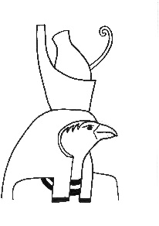
Ancient Egyptians – Mummification (KS2)
Learn about the process of mummification and the beliefs of the Ancient Egyptians. Sequence the process and match photographs of our artefacts to the process. Some images will be shown on screen and others will be emailed to the school ahead of the workshop to be printed for use during the session. Minimal resources will be needed.

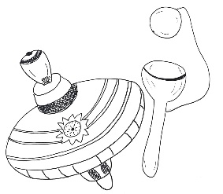
Toys through Time (EYFS/KS1)
Learn about the toys we have on display in the museum, with focus on materials and comparing to modern versions. This includes a short pre recorded film of the Toys in the gallery.

Dinosaurs (EYFS/KS1)
Identify different fossils, learn how they are made and what we can discover about dinosaurs by studying their bones. Dinosaur impressions included and encouraged!! Practice those dino roars!
Prehistory – Stone Age (KS2)
Learn about the life of stone age people, the tools they used to hunt and gather to survive. Some images will be shown on screen and other will be emailed to the school ahead of the session to be printed for use in the session.

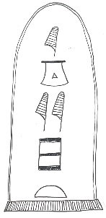
Ancient Egyptians – Hieroglyphics (KS2)
This session is based on objects in our Ancient Lives Gallery which will be seen in a short film included in the session. Learn about who, how and when hieroglyphics were first translated and how it helped historians understand reasons and uses of different objects. Includes a hieroglyphic writing activity. (linked to film on website)

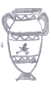
Ancient Greeks (KS2)
Learn about the people who used different objects and their beliefs. Learn about key features of the gods, and virtually sort objects according to their links to the gods. There is some standing and moving activity in this workshop.

Please complete the below information and send it to museumeducation@maidstone.gov.uk
We will send back a confirmation document once date agreed.
Today’s Date:
Contact name and email:
(this is where the Teams link will be sent)
School name and address:
School/finance email – for invoice (this is sent at the end of the month of visit):
School phone number:
School type: (please circle) | Academy / Local Authority / Free / SEND / Other
Add to mailing list for schools offers: | Yes / No
School DFE/URN Number:
Year group;
Number of children;
Number of classes;
Schools can either have a combined session (ie 2 classes on the Teams meeting at the same time) or individual sessions (2 separate times) We charge £60 for the first class, with a reduced rate of £30 for additional classes attending the same session. If classes have separate sessions the charge is £60 per class.
Please choose preferred option; | classes together (£60 plus £30 per additional class) | classes separately (£60 per class)
Session chosen;  Toys (EYFS/KS1)  Dinosaurs (EYFS/KS1)  Egyptian Hieroglyphics (KS2)  Egyptian Mummification (KS2)  Stone Age (KS2)  Ancient Greeks (KS2) | Time Chosen;  10am,  11am,  1.00pm | Preferred Date; please give options (Tuesdays only)

