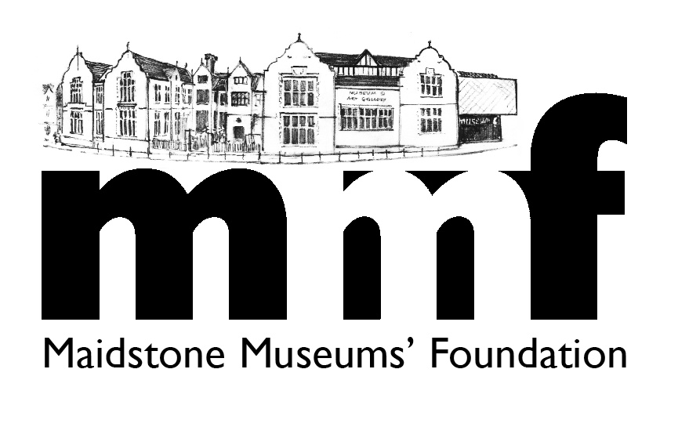
Policy 1

FUNDRAISING POLICY

1. The Foundation is established to raise the profile of Maidstone’s Museums and to provide support to them in every way. It does this by:

a) promoting the three Museums to the residents of Maidstone, and
beyond;
b) securing finance to help with the purchase of artefacts,
display, restoration of works, improved display, &
improvement/adaption of the buildings - through grant-
giving trusts, local fund-raising activities, donations, and the
membership scheme; and
c) co-ordinating and operating the membership (Friends’) scheme.
2. The fund-raising agenda (b) is thus broad and there are no set limits on the minimum and maximum amounts of finance that the Foundation will seek to raise on any individual project.

Need

It is important to spell out two types of need for the Museums.

3. Small Projects - the identification of on-going pressures involving small sums of money (normally less than £5,000 per project). These can be – the restoration of an artwork or artefact, orientation materials, or the purchase of a small item of equipment, etc. The Foundation Board expects there to be an advance priority list of small works the Museums wish to address. For each bid (which may be made at any monthly Board meeting) there needs to be clear demonstration of need put forward by the Museums. It is recognised that sometimes a project may be driven by urgency or by opportunism, and these will be considered on their merits. Foundation finance is considered against the situation of the Board’s current accounts and forward budget.
4. Major Projects – the identification of significant capital works needed, consistent with the Museums’ medium term plan. The project(s) need to be of -
* long term benefit for the Museums,
* be value for money, and
* be sustainable beyond the project itself.
In some cases the Board will consider large purchases of art or artefacts, based upon a firm cultural case. As with small projects, this must be agreed by the Foundation Board.
Naturally, this project will be led by Museum staff, but it is especially important for the Foundation to be a contributor in full project planning, and for it to be crystal clear about (and be in acceptance of) the amount being sought from the Foundation.

5. Normally, the Foundation will only pursue one major project at a time, because – fundraising may take many years; clarity needs to be given to Foundation Friends, and other supporters, about the relevant fundraising ‘campaign’; and all efforts (by the Foundation and Museums) need to be concentrated on one objective at a time.

Decision Making

6. In all fundraising it is imperative that Maidstone Museums’ Foundation works closely with the staff of the Museums. In most instances the Museums’ management will set out their needs against a robust cultural case, and there will be joint agreement and working. However, it is accepted that there will be instances where the Foundation feels strongly about an element, and will drive an agenda (subject to Museums’ staff agreement). But in both cases there must be partnership in final decision-making, and never any confusion created by unilateral bids for third party finance.
Fundraising

7. There is a multi-pronged approach to the Foundation’s fundraising activities.

8. MMF Subscriptions – there are various categories of membership (single, couple, family, corporate and life) which provide people with various benefits (as Friends) in the Museums. The current income stream is not huge, but is constant annually.

9. Events – a whole variety of activities which include – visits to external historical destinations, events within the Museums themselves, attendance at local fairs, etc. All of these are arranged and conducted by the Board and some Friends (ie volunteers). They have multi-purposes – to raise the profile of the Museums, to encourage greater membership of MMF, promote events of interest to Friends and guests, etc. However, we ensure that all such activity does break even and, hopefully, ends with a net financial surplus, for MMF work.
10. Fundraising Events – these are dedicated events with the express purpose of raising finance toward an overt project. All attendees are aware of the ‘funding campaign’, the need identified, and the target. Again, they are organised by the Board and Friends (ie volunteers).

11. Collection Boxes – there is a collection box at the entrance/exit to the main Museum, and visitors are requested to contribute to the Museums’ development. It is made clear that all donations are to the Foundation, a charitable body, which in turn supports Maidstone Museums. Plans are progressing to purchase another such box to be installed in a designated gallery and, if successful, this may be duplicated elsewhere.

12. Personal Donations – these are encouraged at all times through the Foundation membership leaflet and two-monthly electronic newsletter to all Friends. This approach has more likelihood of some success if an overt campaign for a Major Project is being promoted and is well articulated.

13. Sponsorship – specific sponsorship for certain projects is always encouraged, but any such negotiation must be in conjunction with Museum management. There may be inducements, such as naming opportunities, which the Museums must agree.

14. Grant-Giving Trusts and Foundations – approaches to these are conducted according to a clear strategy for each campaign for a Major Project. There will be ‘target’ trusts according to the type of project for which financial support is being sought; there will be differing financial support levels by each trust (if successful); and there will need to be a plan of how to raise the total required when individual trusts can only meet part of the total sought.

Strategy for each Fundraising Campaign

15. For each clearly demonstrated need, and acceptance by the Foundation board of its involvement, there is required to be a strategy for the specific fundraising ‘campaign’. This will be so especially for any major project. There must be awareness of the approach to be taken, the mix of activities to be used, and the sources to be targeted. Because ‘fundraising’ is not easy and there is much competition for support requests there needs to be ‘plans B, C, D’ (and so on) and a willingness to adopt them if necessary.

16. This policy, therefore, is to set down the agreed principles of the Foundation approach to fundraising.

October 2015

