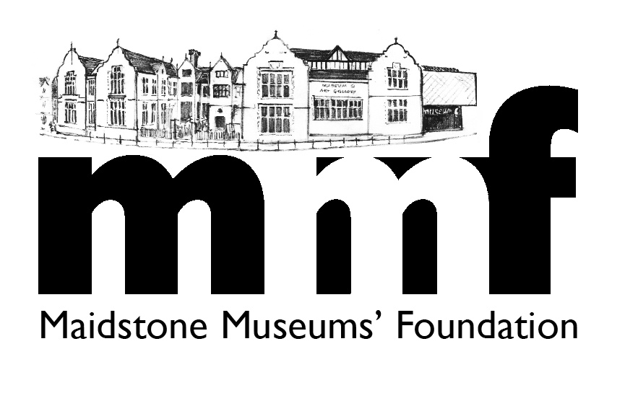

FULLER PROFILES OF TRUSTEES

Mark Baker (Chairman) (Businessman – property)
He was born, educated and still lives in Maidstone. He runs the family owned investments company. From 1976-82 he served as a Maidstone Borough Councillor. Has served as a Trustee of the Heart of Kent Hospice, Chairman and then Executive Chairman of the Kent Air Ambulance. He is currently a director of the Maidstone Town Centre Management Initiative.

Elaine Craven MBE (Vice Chairwoman) (Businesswoman – recruitment)
She lives in Maidstone, and founded her company, Earl Street Employment, in 1977. During this time she has been an active member of the local community, becoming the first woman to be elected to an Executive position within the Chamber of Commerce. She has been a Trustee of both the Kent Air Ambulance and the Heart of Kent Hospice, a founder member of two successful business clubs plus the Dawn Patrol Rotary Club. Since 2001 she has assisted in the running of the Maidstone Young Musician of the Year.

Stephen Farrant (Treasurer) (Businessman – accountancy)
He lives in Sussex. As a practising Chartered Accountant, his day job is spent working as a partner of Wilkins Kennedy, one of the MMF’s corporate members, where the client portfolio includes a number of clients in the Charity sector. He has been a trustee of the MMF charity for almost 10 years. His role on the board is that of honorary treasurer, so he takes overall responsibility for the accurate recording and presentation of all things financial as they relate to the Foundation.

Trevor Sturgess DL (Secretary) (Businessman – media)
He lives in Maidstone. He is a former Business Editor of the Kent Messenger Media Group, setting up the multi-media company's business desk and co-founding its monthly Kent Business. He has worked overseas as a journalist and won several awards. He is a Deputy Lieutenant of Kent. He has been MMF secretary since 2014.
Hazel Arnold (Membership Secretary) (Retired – ex insurance)
She lives in Maidstone. She is a retired insurance professional, organised and enthusiastic, lover of history and general knowledge. She has managed the Friends’ membership (of MMF) database since May 2014.

Moira Bennett (Teacher – Invicta Grammar School)
She has lived in Headcorn, near Maidstone, since 1994. She began teaching in 1972 in Derby as a Geography teacher. Since then she has always continued her core geography teaching but with special responsibilities for careers, sixth form and more recently since 1994, at Invicta Grammar School (Maidstone) as Community and Enterprise Co-ordinator. She has also been a governor at Invicta for more than 10 years as a staff representative. She joined the MMF Board in 2016 as school representative giving an educational perspective to the Trustees.
Ilsa Butler (Town Centre Coordinator, One Maidstone CIC)
Ilsa has always lived in the Borough of Maidstone and has worked at Maidstone Town Centre Management for over ten years. Town Centre Management has now merged with Maidstone Town Team and Ilsa is the Town Centre Co-ordinator for this new Community Interest Company – “One Maidstone”. She has also worked in association with MaidSafe and is on the Kent Business Crime Group.

Mike Evans FRSA (Retired – ex economic development manager)
He has lived in Maidstone since 1974. Between 1974 and 2006 he worked for Kent County Council, the last 20 of which were in senior managerial positions. He was Chairman of Trustees at Maidstone Community Support Centre (2005-2016), Secretary of Maidstone Hockey Club (2006-2016), and is currently Chairman of the Friends of South Park Group. He has edited and produced the MMF 2 monthly on-line newsletter since July 2014, the MMF website content since February 2016, and co-ordinates fundraising efforts. He is also a Trustee of the umbrella group, British Association of Friends of Museums (BAFM) and is Regional Co-ordinator for the South East, Southern Counties.

John Newcomb (Businessman – law)
He has been a Kent resident since 1984 and has served his local community in a variety of capacities since that date. He is a practising solicitor and a partner at SNS Solicitors, one of MMF's corporate members. Since opening an office in Maidstone he has become a firm supporter of the town; its history and heritage.

Ivan White (Businessman – retail)
He was educated and still lives in Maidstone. On leaving school he joined the family photographic business in the town centre. He is involved with many activities that promote Maidstone and small businesses. Interests include gardening, cooking and music especially jazz of which he proudly sponsored the Maidstone Jazz festival for 3 years.

Cllr. David Pickett (Chairman of MBC’s Heritage, Culture & Leisure Committee)
He has lived in Maidstone since 1995. Until his retirement he managed a large toy store in the town centre. Since arriving in Maidstone he has taken a proactive interest in local politics and was elected Councillor for Bridge Ward in the May 2010 elections. He is keen on history, art and culture, and is an amateur film maker. He is President of Maidstone Choral Union and a member of Maidstone Wind Symphony. member of the Sherlock Holmes Society of London, and member of the English Civil War Society.

Victoria Barlow (Maidstone Museums’ Director)
She has been working in museums since 1995. She has been employed in a variety of curatorial roles at museums across the country, including The Historic Dockyard, Chatham. Her professional area of expertise is community engagement and contemporary collecting, particularly in social history. Interests include visiting historic sites, reading and her 3 pet guinea pigs!

